***Access modifier :***

*It decides the visibility of class, method or variable and constructor.*

1. *Class : public & default.*
2. *Method : public, protected, default & private.*
3. *Variable : public, protected, default & private.*
4. *Constructor : public, protected, default & private.*

***Private*** *: Methods, variables, and constructors that are declared private can only be accessed within the declared class itself. Exapmle in eclipse.*

***Default*** *: If you don't use any modifier, it is treated as default by default. The default modifier is accessible only within package. Exapmle in eclipse.*

***Protected*** *: The protected access modifier is accessible* ***within package and outside the package*** *but* ***through inheritance*** *only(parent child).* ***WE WILL DISCUS THIS AT TIME OF INHERITANCE.***

***Public*** *: The public access modifier is accessible everywhere. It has the widest scope among all other modifiers. Exapmle in eclipse.*

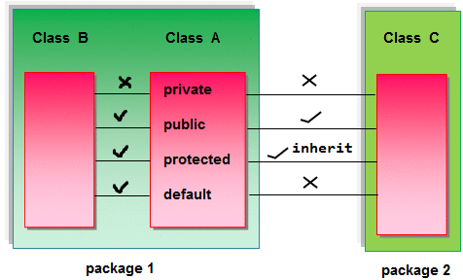

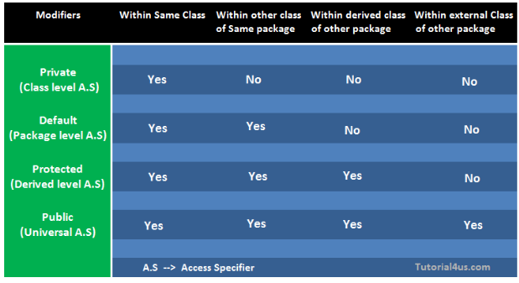***Proctected***

*In this example, we have created the two packages pack and mypack. The A class of pack package is public, so can be accessed from outside the package. But msg method of this package is declared as protected, so it can be accessed from outside the class only through inheritance. Eclipse : protectedDemo2 and protrctedDemo1*

1. *//save by A.java*
2. ***package****pack;*
3. ***public******class****A{*
4. ***protected******void****msg(){System.out.println("Hello");}*
5. *}*
6. *//save by B.java*
7. ***package****mypack;*
8. ***import****pack.*;*
10. ***class****B****extends****A{*
11. ***public******static******void****main(String args[]){*
12. *B obj =****new****B();*
13. *obj.msg();*
14. *}*
15. *}*